SAMPLE LESSON PLAN*
Class: VI
Subject: SCIENCE
No. of Periods: 6 in a week
Unit 3: THE WORLD OF THE LIVING
Chapter 7: LIVING AND NON-LIVING
PREVIOUS KNOWLEDGE:
The students are aware that humans, plants and animals show different activities while others like stone, table, chair do not. Thus they are living things while others are non-living. They know that all living and non-living things are made up of matter. Matter occupies space and has mass. Thus all living things and non-living things occupy space and have mass.
INTRODUCTION:
The lesson can be introduced with a story of the Italian scientist Lazzaro Spallanzani in the 18th century. He experimented with a lump of decaying meat which developed maggots. From this experiment, he wanted to prove the thought of many people as about 200 years ago that living things can be developed from non-living things suddenly. But in 19th century Louis Pasteur proved that this was not correct. Maggots could be developed from maggot eggs only which were not visible under naked eye.
LEARNING OBJECTIVES:
The students will be able to understand –
- Common features of living and non-living things.
- Differences between living and non-living things.
- Characteristics of living things:
  - All living things are made up of cells (ii) Living things grow
(iii) Living things have a definite lifespan (iv) Living things reproduce
(v) Living things respond to various stimuli (vi) Living things need food to grow and to do various activities
(vii) Living things excrete (viii) Living things respire
- Species: A group of similar living organisms is known as a species
METHODOLOGIES:
1. Story telling | 2. Discussion | 3. Demonstration
4. Pair activity | 5. Group activity | 6. Observation and inference
7. Experimental investigation
TEACHING AIDS:
1. Coursebook – Living Science 6 | 2. CD provided with the book | 3. Chalk and blackboard
4. Glass slide | 5. Onion peel | 6. Microscope
7. Mimosa plant | 8. Soaked seeds
ACTIVITIES:
The following activities/experiments could be done:
- To observe cells of an onion peel as plant cells under a microscope
- To observe animal cells of inner lining of our cheek under a microscope
- To touch a Mimosa plant in school garden
- To observe a sunflower during daytime
- To observe photographs or mounted models of Amoeba, Paramecium, Hydra, and Hibiscus flower
- To observe growth in moong or chana seeds
- Experiment to show that plants repond to light especially, the stem part grows towards the light and root grows opposite to light, i.e. phototropism
- Experiment to show that roots grow towards water or earth, i.e. geotropism
Living Science Companion – 6
- To observe stomata under a microscope
- To observe the response in an earthworm or cockroach to light
ASSIGNMENTS:
- Class Assignment or Classwork:
  - Activity 1 to be done in Class 2. Q. A, B, C to be discussed and done in Class
3. Q. D to be discussed in Class 4. New terms like cell, Amoeba, Paramecium, stimulus,
phototropism, geotropism should be defined
- Home Assignment or Homework:
  - Activity 2 to be done at home 2. Q. D – answers to be written in notebook at home
- Figures 7.2b, 7.6a, 7.7 to be drawn in notebook

* The following lesson plan is meant to be a sample. It is suggestive of the kind of lesson plans that would be useful in planning the teaching programme for the
year. It can be modified to suit the needs of the school.
1

SOURCES OF FOOD
- 8 Oral Questions
  - Food helps the body to grow and replace
worn-out cells; food also protects the body from
diseases and keeps it fit and healthy.
  - Plants, as the teeth in the animal found are of cutting and grinding types.
  - No, because all animals are dependent on green plants for food directly or indirectly.
  - False. Green plants prepare their own food from non-living things and also they prepare more food than they need. But we make our food from living things that is either plants or animals. So we eat the food prepared by plants directly or indirectly.
P. 9 Exercises
A. 1. c 2. b 3. a
4. c 5. d 6. a
- 1. potato 2. omnivores 3. scavengers
4. false 5. nutrients 6. no
- 1. The sources from which we get the ingredients used in food are plants and animals.
- Green plants are known as producers because they make their own food from non-living things such as carbon dioxide, water and sunlight.
- Potato – stem Spinach – leaves Carrot – root
- Scavengers mainly consume dead bodies of animals and help to keep the surroundings clean. In this way scavengers are useful to the environment. For example, crows, jackals and vultures are scavengers.
- Mosquito lives on blood, a liquid, which it sucks from humans and other animals. So it does not have teeth but a pipe like structure to suck blood.
- No. We make our food from living things that is either plants or animals. But water and salt are two things that we get from the earth.
- 1. Honeybees use nectar to make honey. They collect nectar from flowers and take it to their hive. There they convert it into honey and store it as food.
- The difference between herbivores, carnivores and omnivores:
Living Science Companion – 6
  - Herbivores are animals that eat plants. For example, cows, goats and so on.
  - Carnivores are animals that eat the flesh of other animals. For example, lions, tigers and so on.
  - Omnivores are animals that eat both plants and animals. For example, bears, crows and so on.
- The functions of food are:
  - It provides energy for various activities of the body.
2
  - It helps the body to grow and replace worn- out cells.
  - It protects the body from various diseases,
thus keeping it fit and healthy.
- A food chain shows how each living thing gets its food in a particular environment. For example, a grasshopper eats a green plant, a
frog eats the grasshopper, the frog is eaten by a snake, and the snake is eaten by an eagle.
- Herbivores eat plants. So they have sharp, cutting teeth in front and flat, grinding teeth at back. Carnivores eat the flesh of other animals. So they have long, sharp teeth to tear the flesh.
- Parasites are small animals that depend on other living animals for their food. For
example, mosquito lives on blood that it sucks from humans and other animals. Others like tapeworm and hookworm live inside the bodies of animals and eat the food after it is digested.

HOTS Questions
- A carnivore is an animal that gets food by killing and eating other animals. For example, lions and tigers. On the other hand parasites are small animals that obtain their food from living animals. For example, mosquitoes and fleas.

- Canines or tearing teeth.
- The disappearance of any organism in the food chain can make a huge impact on the entire food web. Each organism in a food chain plays an important role in nature. If even one organism is eliminated, an imbalance is created in nature. For example, in the given food chain (grains rats snakes
eagles) if all the snakes were killed this would lead to an increase in the population of rats, which in turn would destroy crops and grains. Similarly, eagles will also suffer due to non- availability of snakes as food.

Be a Scientist
- Leaves → Earthworms → Sparrows → Eagles Berries → Flies → Frogs → Eagles
(other food chains also possible)
- a. Squirrels will increase.
b. Earthworms will decrease (as the number of sparrows will increase).

2. COMPONENTS OF FOOD
- 16 Oral Questions
  - carbohydrates, fats, proteins, vitamins, minerals
  - sugary food, sugars release energy quickly than other energy giving foods
  - They do not provide us quick energy. But when we are short of energy, the body uses them.
  - A 10-year-old child. It is necessary for growth of the body which is the case for the child. Per

kilogram body weight is specified here because protein requirement increases if your weight is more.
  - plant food, it is a kind of carbohydrate

20 Oral Questions
  - a. kwashiorkor
    - night blindness
  - a. rickets, deficiency of vitamin D
    - scurvy, deficiency of vitamin C
    - anaemia, deficiency of iron
    - goitre, deficiency of iodine in the diet
P. 21 Exercises
A. 1. c 2. a 3. c
4. b 5. d 6. a
7. a 8. b 9. d
10. d
- 1. deficiency 2. true 3. skin
4. vitamin D 5. calcium 6. water
7. balanced 8. true 9. false
10. vitamin C
- 1. Nutrients are divided into the following classes:
  - Carbohydrates give us energy to work. For example, starch, sugar and so on.
  - Fats give us more energy than starch or sugar. For example, oil, nuts and so on.
  - Proteins help us to grow. For example,
eggs, fish and so on.
  - Vitamins are essential for the proper working of the body. For example, milk, green leafy vegetables and so on.
  - Minerals are required by our body in small quantities in the diet to maintain good health. For example, liver, eggs, milk and so on.
Carbohydrates and fats provide energy to the body. However, carbohydrates give instant energy.
- Foods rich in vitamins and minerals are known as protective foods. They protect our body against diseases. They are essential for the proper working of the body and to maintain good health.
- Proteins are needed for the growth and repair of the body. They build new cells and hence are body-building foods.
- Cooking in too much water and high or prolonged exposure to heat. For example, vitamin C gets destroyed during cooking due to heat.
- Sugars and starch are two kinds of carbohydrates. Sugars provide us quick energy.
- Vitamins and minerals are needed by our body in small quantities only.
- In rickets, bones become soft and hence get bent and deformed. Bow legs, pigeon-type chest, and bending of the spine are symptoms of rickets.
- In marasmus, the child becomes very thin and loose folds of skin can be seen all over the body.
- The incidence of goitre among the people living in the Himalayan region was quite high because the iodine content of soil and water is low there.
- 1. a. For normal growth, healthy eyes and skin.
- For healthy growth and strong blood vessels.
- Helps to use calcium for formation of strong bones and teeth.
- Helps in the clotting of blood.
- a. For strong bones and teeth.
- For the proper functioning of the nervous system.
- For growth, for keeping cells and blood healthy.
- For the formation of the substance that helps red blood cells carry oxygen to body cells.
- We should drink 6–8 glasses of water every day because life processes cannot occur without water. It only serves as a solvent in which all chemical reactions take place. It helps our body to absorb nutrients from food and transport them throughout the body. It collects wastes from different parts of the body, and removes them from the body in the form of urine and sweat.
- A balanced diet is one that contains the proper amounts of each nutrient. However, balanced diet is not the same for everyone. It depends on age, sex and the type of work that one does.
- Diseases caused by lack of essential nutrients such as vitamins and minerals are known as deficiency diseases.
The four deficiency diseases and the
associated nutrients:
  - Night blindness is caused by the deficiency
of vitamin A.
  - Beri-beri is a disease caused by the
deficiency of vitamin B1.
  - Anaemia is caused by the deficiency of iron.
  - Goitre is caused by the deficiency of iodine.
- Roughage adds bulk to our food. It prevents constipation and ensures proper bowel movement. It also reduces the risk of heart diseases and bowel cancer.
Living Science Companion – 6

HOTS Questions
- Constipation is common among people in the western countries who eat more meat and processed food and not enough plant food because of a diet low in fibre necessary for the proper functioning of the digestive system. Fibre adds bulk to the food and
prevents constipation by ensuring proper bowel movement.
3

- No. Because the engineer does not do physical work and hence does not require the extra calories that eating more carbohydrates and fats will provide. In fact this may make him gain weight and hence become less healthy.
- No. because though milk contains most nutrients, it does not provide roughage which is essential for proper digestion and bowel movements.
- In such a voyage it would be difficult to get fresh fruits and vegetables that are necessary to provide vitamin C, a lack of which would lead to gum problems (scurvy).

Be a Scientist
A-Protein; B-Water; C-Carbohydrate; D-Fat

3. FIBRE TO FABRIC
- 28 Oral Questions
  - Yarns are made up of fibres.
  - Cotton, silk
  - natural fibre
  - No. In knitting, a single yarn is used to make a fabric but in weaving two sets of yarns are used.

30 Oral Questions
  - Silk is smoother than cotton and shiny in appearance
  - boiling silkworms in their cocoons
  - Jute is not normally used to make cloth because it is a coarse and heavy fibre in comparison to cotton, silk and wool.
  - nylon, polyester; synthetic fibres
P. 31 Exercises
A. 1. a 2. a 3. b 4. b
5. c 6. c 7. c 8. c
- 1. a. cotton b. silk c. wool d. nylon
2. black, alluvial 3. moderate
4. Sericulture 5. true
6. heavy 7. retting
8. true 9. spinneret
- 1. We wear clothes mainly to protect our bodies against the weather, i.e. strong sunlight, extreme cold or heat, and rain. Clothes also protect us from insects.
Living Science Companion – 6
- People covered their bodies with animal skins in cold regions, and with bark, leaves and grass in warmer regions.
- Fibre: A natural or synthetic thread that may be spun into yarn.
Yarn: Yarns are made up of fibres.
- Wool, cotton, silk and nylon are the four fibres that are used to make clothes. Leather and fur are not fibres, but are used to make clothes.
- Jute is used chiefly to make cloth for wrapping bales of raw cotton, and to make sacks and coarse cloth.
4
- Clothes made from synthetic fibres are stronger and do not wrinkle easily. They also dry up easily. They are often mixed with natural fibres to make cloth which has strength and can also breathe and absorb sweat.
- Because in India, a tropical wet and dry climate is more common. Nylon or polyester clothes cannot absorb sweat and does not breathe like cotton. These properties make them unsuitable for hot and humid weather.
- Jute grows best in warm, humid climates, with plenty of rainfall. It grows best in alluvial soil. The Sunderbans perfectly matches all these criterias.
- 1. Cotton is a warm season crop requiring moderate rainfall. It needs a fertile clayey soil with good moisture holding capacity. Black soils found in western India and southern India, and alluvial soils of northern India are suitable for growing cotton.
- The steps involved in converting cotton growing on plants to cotton cloth are
  - Ginning: Fibres are separated from the seeds by combing. This process is known as ginning.
  - Spinning: Fibres are then spun into yarn, by drawing out and twisting the fibres together. This process is known as spinning.
  - Weaving: The yarn is then used to make cloth by weaving.
- Cotton cloth is soft and lets air in. It also absorbs sweat. This results in the cooling down of the body. Cotton clothes are, therefore, comfortable to wear, especially in hot, humid weather. On the other hand, clothes made
from synthetic fibres have less air spaces in them than natural fibres and do not ‘breathe’ so well. They also cannot absorb sweat. These properties make them unsuitable for hot and humid weather.
- Wool is derived from the hair on the body of sheep and some other animals. First of all wool is removed from the sheep using special clippers and the process is called shearing. After shearing the wool is packed in bales and transported to the mills. Here it is cleaned and then combed by a machine, separated and spun into fibre. This fibre is then woven or knitted to make woollen clothes.
- Silk is obtained from the cocoon of the silkworm. The cocoon is boiled in water to kill the silkworm and then unwound to get silk fibre.
- After harvesting the stalks of the plants are tied into bundles and retted (soaked) in water

for about 20 days. This process softens the
tissues and permits the fibres to be separated.
The fibres are then stripped from the stalks
in long strands and washed in clear, running water. Then they are hung up or spread out to dry.

HOTS Questions
- Because air gets trapped in between the layers of cotton clothes and acts as an insulator. It does not allow heat to escape.
- Silk has come under fire from animal rights activists because the process of harvesting the silk from the cocoon kills the larvae in a very cruel way by boiling them alive.
- Cotton or wool naturally has a fibre shape. Nylon has to be moulded into the shape of a fibre by melting and then forcing it through a spinneret.

SORTING MATERIALS INTO GROUPS
- 37 Oral Questions
  - occupying space and having mass
  - air, water; feelings of love, TV signals
  - a. atom b. molecule
  - similar properties
  - yes

41 Oral Questions
  - sugar, milk, oxygen
  - float
  - transparent
  - as their arrangement of molecules are different from one another
P. 42 Exercises
A. 1. a 2. c 3. d
4. b 5. c 6. d
7. b 8. c
- 1. wood 2. volume
3. atom 4. molecule
5. feelings 6. classification
7. false 8. shine
9. gases 10. no
11. oxygen 12. density, density
13. translucent
- 1. Five materials are
  - steel – utensils
  - plastic – bottles
  - wood – furniture
  - cotton – clothes
  - leather – shoes
- Anything that occupies space and has mass is called matter. For example, water, air and so on.
The two things which are not matter are feelings of love or sadness.
- All matter occupies space and has mass.
- The smallest particle of an element is an atom
whereas the smallest particle of a compound is a molecule.
- The feeling of a surface or substance, i.e. the smoothness, roughness, softness and so on is known as texture.
- Because some metals lose their lustre when exposed to air and moisture.
- Paper can be made translucent with a coating of oil.
- Atoms join together to make molecules. Millions of different kinds of molecules can be made from these 118 different kinds of atoms. That is why we see millions of compounds all around us.
- 1. Grouping together things with similar properties is called classification. It is useful because it makes studying the properties of things much easier.
- Although living things share some common properties, they differ from each other in several ways. Living things are further classified into subgroups such as plants and animals. Each of these can be further classified based on certain properties. Animals can
be classified into groups like insects, fish, amphibians, reptiles, birds and mammals. For example, all insects have six legs. But each group differs from other groups in some ways.
- The three states of matter are
  - solids – definite shape and volume
  - liquids – definite volume, but no definite
shape
  - gases – no definite shape or volume
- Water causes all molecules in a solid piece of sugar to break apart. The individual molecules, when separated, are so small that we cannot see them. In this way sugar dissolves in water.
- The mass per unit volume of a substance is known as density. A substance which is less dense than water will float on water. Substance which is denser than water will sink in water.
- Liquids which mix with each other are called miscible liquids, for example, milk and water. Liquids that do not mix with each other are called immiscible liquids, for example, oil and water.
Living Science Companion – 6
- Almost all light can pass through transparent objects, for example, air and clear water. Whereas light cannot pass through opaque objects, for example, book and a stone.

HOTS Questions
- Thermocol, paper
- No. That is why chalk does not dissolve in water.
- Water, because ice floats over its surface.
- The force between the molecules will be the same as long as the distance between them is the same.
5

Crossword:
Across Down
  - MOLECULE 2. OXYGEN
4. GAS 3. ELEMENT
6. GOLD 5. ATOM
9. CLASSIFICATION 7. SOLID
8. DALTON

Be a Scientist
Fig 1: A has greater density (since it has smaller volume but is heavier)
Fig 2: C has greater density (since C and D have the same volume but C is heavier)
Fig 3: Not possible to say which has greater density

5. SEPARATION OF SUBSTANCES
- 49 Oral Questions
  - mixture
  - mixtures
  - homogeneous
  - it is a pure compound
  - to remove undesirable constituents; to obtain useful constituents;
to obtain pure substances
- 54 Oral Questions
  - a. evaporation
  - sedimentation and decantation
  - adding water, then filtration and evaporation
  - loading
  - immiscible

56 Oral Questions
  - Because, the individual particles of sugar break up into molecules and are evenly spread in the open spaces among the molecules of water.
  - Salt, sugar; wood, sand
  - No
  - Yes
P. 57 Exercises
A. 1. d 2. b 3. c 4. c
5. a 6. b 7. c 8. d
9. b 10. a
- 1. true 2. false
3. homogeneous 4. boiling point
5. true 6. no
Living Science Companion – 6
7. filtration 8. loading
9. winnowing 10. evaporation
11. distillation 12. Liebig’s condenser
13. separating funnel 14. fractional
15. true 16. yes
17. false
- 1. Pure water at sea level boils at 100 °C. However, if there are dissolved substances in the water, its boiling point goes up. Thus, by measuring the boiling point we will know whether the water is pure or not.
6
- To separate a mixture into its constituents we have to use some property that one constituent has while the others do not have.
- The size of the holes of the sieve should be bigger than the size of sand particles and smaller than the size of rice seeds.
- The filter paper has fine holes which allow a liquid to flow through, but not the particles of an insoluble solid. This helps it to separate the insoluble solid from the liquid.
- The temperature of a saturated solution is specified because the solubility of most substances increases with temperature.
- Handpicking can be used to separate the constituents of a mixture only when the particles of the undesirable substance have different colour, shape and size and are present in small quantities.
- Objects at a distance are seen more clearly after rain as loading of dust particles in air takes place when it rains. The dust particles become heavier and settle on the ground.
- To load means to make it heavier. In loading, the fine suspended particles are made heavier to make them settle down.
- 1. The constituents of a homogeneous mixture cannot be seen separately, for example, sugar in water, whereas the constituents
of a heterogeneous mixture can be seen separately, for example, chalk powder in water.
- The three properties of mixtures are
  - The constituents of a mixture may be in any ratio.
  - The constituents retain their individual properties.
  - The constituents can be separated by simple methods.
- (i) To remove undesirable constituents
for example, harmful substances present in river water.
(ii) To obtain useful constituents
for example, butter can be obtained from milk or curd by churning it.
4.

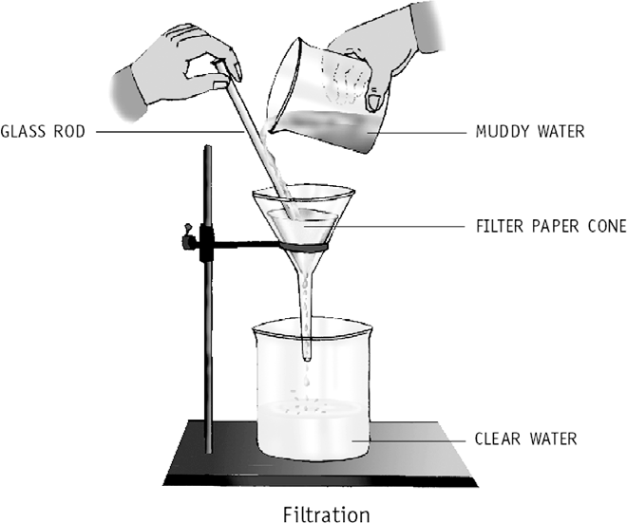

5.

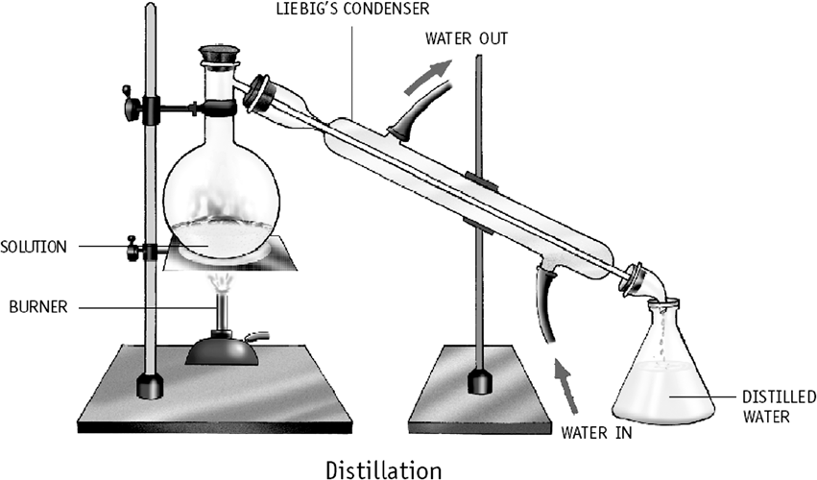
- First of all we remove pebbles by hand picking.
Grass can be separated by filtration and sand can be separated by sedimentation and decantation.
- Pour oil and water in a separating funnel and let it stand for some time. You can clearly see two layers – water at the bottom and oil on top. Carefully turn the stopper of the funnel and allow the water to flow out into a beaker placed below the funnel. Stop the flow as soon as the layer of oil reaches the stopper.

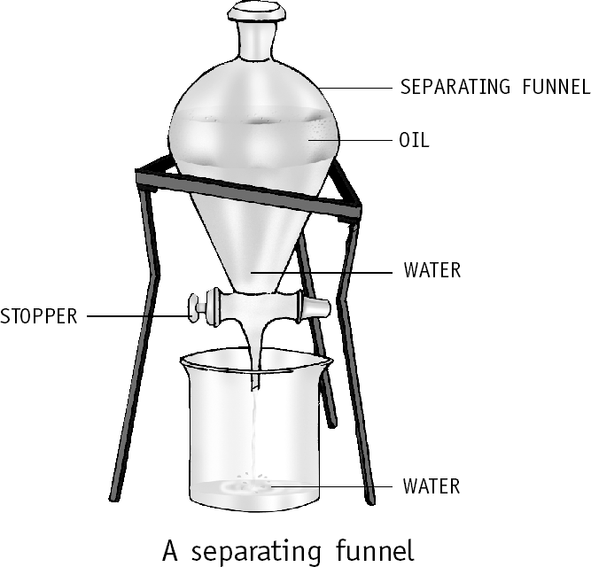
- In the process of digestion, food is reduced to simple substances that are soluble in water. They can then be dissolved in water and absorbed by the body. Several waste materials produced in the body are dissolved in water and excreted. A number of chemical reactions occur inside our body. They all occur in the presence of water. Plants can absorb nutrients from the soil only if they are soluble in water. Minerals from the roots and food from the leaves are transported to different parts of the plant in the form of solutions in water.

HOTS Questions
- By mixing a small amount of it with water – salt will dissolve in water whereas chalk will not.
- Filter the mixture. The residue on the filter paper will be a mixture of sand and iron filings. Dry the residue and roll a magnet in it – the iron filings will stick to the magnet and get separated. The filtrate will be a solution of salt and water. Use distillation to get pure water.
The salt will be left behind after all water has evaporated.
- No change.
- Yes. The solubility of sugar in water reduces with decrease in temperature. Therefore when the temperature is lowered, some sugar will separate out but the solution will continue to be saturated.
- Because it is an expensive method.

Be a Scientist
- Using a magnet; Using a sieve
- By using a separating funnel

6. CHANGES AROUND US
- 66 Oral Questions
  - chemical
  - No
  - They have different physical properties and their molecules are exactly the same. So, melting is a physical change.
P. 67 Exercises
A. 1. a 2. b 3. c
4. b 5. d 6. c
7. b 8. c
- 1. true 2. true
3. physical change 4. physical change
5. irreversible 6. no
7. no 8. physical change
- 1. Physical changes: tearing of paper Chemical changes: burning of paper
Reversible changes: molten wax becomes solid again when cooled
Irreversible changes: cooking of food
- Shaping of pots: Reversible change Baking of pots: Irreversible change
- On breaking a glass tumbler, no new substance is formed as the molecules of glass remain the same but in burning of a paper, smoke and gases are given out, that is, new substances are formed. Hence, breaking of a glass tumbler is a physical change whereas burning of paper is a chemical change.
- Cooking of food is a chemical change. This is because the original molecules change to form new substances with different properties and this cannot be reversed.
Living Science Companion – 6
- No. Most physical changes are reversible.
- Growth is a chemical change. This is because the substances that make up the cells in a body are different from the substances present in food, that is, new substances are formed.
- 1. Physical changes: The molecules of the substances remain exactly the same before and after the change. No new substances are formed. For example, freezing of water. Chemical changes: The molecules of the
7

substances undergo changes to form molecules of new substances. New substances with different properties are formed. For example, burning of paper.
  - Reversible and irreversible changes. Reversible changes: Changes which can be made to occur in the opposite direction are reversible changes. For example, change of state, dissolving of sugar in water.
Irreversible changes: Changes which cannot be made to occur in the opposite directions are irreversible changes. For example, rusting of iron, burning of fire.
  - In a chemical reaction, the initial substances (reactants) react with each other to form new substances (products). For example,
Washing + Lemon Carbon + Other soda juice dioxide products
A chemical reaction has taken place between the reactants, washing soda and lemon juice. Carbon dioxide is one of the products. Other products are also formed.
  - If iron and sulphur are mixed, no chemical change occurs. But when the mixture is heated, it glows after some time and a black substance is formed. The black substance is a different compound with entirely different properties from
those of iron and sulphur. So heating a mixture of iron and sulphur results in a chemical change.
  - The heat of the flame melts the wax. This is a physical change of wax. The liquid wax creeps up the wick by what is known as capillary action. The heat from the flame vaporizes the liquid wax. This is also a physical change. But when the wax vapour burns, it is a chemical change. The heat of the flame keeps melting the wax, thus shortening the candle. Some wax drips down and solidifies again on cooling. This solidification is also a physical change.

HOTS Questions
- No, because on tearing a paper changes its shape and size but it remains paper. No new substance is formed. The molecules of paper remain the same.
Living Science Companion – 6
- No, cooking is a chemical change because it results in new substances being formed. On cooking the molecules that make up the potato undergo changes to form molecules of new substances.
- No, it is a physical change because it does not involve any change in the chemical nature of the two substances involved. When sugar dissolves in water, sugar molecules are dispersed within the water, but the individual sugar molecules are unchanged.
8

Be a Scientist
Figure a shows the water molecules after boiling.

7. LIVING AND NON-LIVING
- 72 Oral Questions
  - Both are made up of matter; both are made up of structural units.
  - The structural unit of non-living thing is a molecule but the structural unit of living thing is the cell.

76 Oral Questions
  - a plant; a car
  - a. bird, human b. yeast, Amoeba
  - In crystal, growth occurs due to addition of material from the outside. Growth in our body occurs by the division of the cells.
  - Upwards, downwards, response to stimuli.
  - produces energy.
P. 77 Exercises
A. 1. c 2. c 3. c 4. c
5. a 6. a 7. d 8. a
- 1. false 2. plants 3. excretion
4. energy 5. Amoeba 6. species
7. false
- 1. Animals move around in search of food or shelter and also to escape from enemies.
- The plant sunflower moves as it turns to face
the sun.
- Cells are the structural and functional units of living things. Yes, all living things are made up of cells.
- Unicellular organisms grow only in size of their cells.
- The leaves of the Mimosa plant droop if we touch it. Touch is the stimulus while folding of the leaves is the response.
- Autotrophs make their food themselves while heterotrophs depend on others for their food.
- Oxygen is the primary need of all organisms. Living organisms respire all the time. The oxygen breathed in combines with the food and produces energy. We need energy to stay alive.
- Urine, sweat and carbon dioxide are three waste products that we excrete.
- 1. All living things are able to respond to stimuli in the external environment. For example, when our hand comes too close to a hot object we pull our hand away from the hot object.
- Growth in living things occurs within the organism by the division of cells. The growth of living things is different from the growth of non-living things because in non-living things growth occurs due to addition of material from the outside.
- Some living things give birth to babies (like

dogs), some lay eggs from which the young ones hatch or produce (like birds) and many plants are produced from seeds or spores.
- (i) Lungs: Most of the mammals breathe through their lungs, for example, humans.
- Skin: The earthworm breathes through its skin.
- Holes: The cockroach breathes through several holes in its body.
- Gills: Fish breathe the oxygen dissolved in water through their gills.
- Plant tends to bend towards the direction from where the light is coming in. This is called phototropism. Roots tend to grow towards the earth and stems grow against it. This is called geotropism.
Animals also show response to light,
for example, cockroach and earthworm move away from light.
- A species is a group of similar living organisms that have similar body parts, live in the
same habitat, eat the same kind of food and reproduce among themselves.

HOTS Questions
- Respiration in plants takes place day and night whereas photosynthesis only takes place during the day. During the day, the amount of oxygen given out by them in photosynthesis
is more than the amount of oxygen used up in respiration. So, during the day, plants supply oxygen to air.
- Because it does not grow or reproduce.
- Matter occupies space and has mass. All living things have mass and occupy space. Hence, living things are matter.
- The prey-predator relationships among animals in jungles keep a check on their population. Also animals do not have health facilities as they are available to the human population.
- Because all the characteristic functions of a living being are carried out by a cell. If a cell is broken up into its different constituent
molecules, each part will die. Hence the cell is the smallest structure that can exhibit life.

8. GETTING TO KNOW PLANTS
- 84 Oral Questions
  - 2 systems, root system and shoot system
  - the fibrous root system; maize, wheat
  - water and mineral salts
  - a. rose b. carrot c. banyan
  - they provide extra support to the branches or the stem

88 Oral Questions
  - water, minerals, food; water and minerals: from roots to the leaves, flowers and fruits food: from leaves to all other parts of the plant
  - potato; stem stores food; Cactus: prepares food and stores water
  - Because the glucose prepared by leaves changes into starch before the plant stores it.
  - Parallel venation
  - give support to the plant, for example, leaf tendrils in pea plant; modified to form spines which helps in reducing loss of water and also protects the plants from being eaten by animals, for example, spines in cactus
  - True, stem tendril in grapevine and leaf tendril in pea plant

90 Oral Questions
  - stamens, pistil or carpel
  - The honeybee gets the honey and in turn transfer the pollen grains from the anther to the stigma and thus the flower gets pollinated.
  - After pollination, the ovary changes into fruit and ovules change into seeds.
P. 91 Exercises
A. 1. b 2. d 3. c 4. b
5. b 6. d 7. c 8. c
9. a 10. c
- 1. non-flowering 2. herbs
3. root system, shoot system 4. fibrous roots
5. stem 6. radish
7. prop roots 8. tendrils
9. lamina 10. reticulate
11. true 12. sepals
13. pollen grains 14. stigma
- 1. Creepers: Plants with weak stems that cannot stand upright, for example, strawberry. Climbers: Plants with weak stems that climb up with the help of a support, for example, grapevine, etc.
- Ginger and potato
- The veins in a leaf transport water, minerals and food, and also provide support to the leaf.
- Pollination is the transfer of pollen grains from the anther to the stigma of either the same flower or of another flower of the same kind.
- Prop roots are the roots growing from the stem or branches of plants like sugarcane and banyan tree. They provide extra support to the plant.
- Leaves make food in the presence of sunlight with the help of water from the soil and carbon dioxide in the air. So the leaf is called the food factory of the plant.
Living Science Companion – 6
- 1. a. Functions of root
  - It fixes the plant firmly to the soil.
  - It helps in carrying water and minerals from the soil to all parts of the plant.
  - It binds the soil particles and prevents soil erosion.
- Functions of stem
- It keeps the plant upright.
9
- It bears branches, leaves, flowers and fruits.

- It transports water, minerals and the food manufactured by leaves, to all parts of the plant.
- Functions of leaf
- The main function of the leaf is to prepare food from water and carbon dioxide in the presence of a green pigment called chlorophyll which traps sunlight to provide energy.
- Leaves are modified to form tendrils that
give support to the plant.
- Leaves are modified to form spines to
reduce water loss.
- Functions of flower
- The flower is the reproductive part of the
plant.
- After pollination, the flower produce seeds
which serve to perpetuate the species.
  - Tap roots: A tap root consists of a main root from which a number of branching roots arise. For example, mustard, pea, and so on.
Fibrous roots: A fibrous root consists of a number of thin fibre-like roots arising from the base of the stem. For example, grass, maize, and so on.
  - Experiment to demonstrate the transportation of water in plants:
The stem transports water to all parts of the plant. Cut a balsam plant at the base. Place it in a beaker half-filled with water. Put a few
drops of red fountain-pen ink in the water and stir. Let the plant stay in the beaker for a day. Examine it the next day.
You will observe thin red lines in the stem and leaves. If the plant has flowers with white petals, we will notice thin red lines on the
petals also. Thus, this activity shows that there are thin tubes present in the stem through which water is transported (or conducted) to all parts of the shoot system.
Living Science Companion – 6

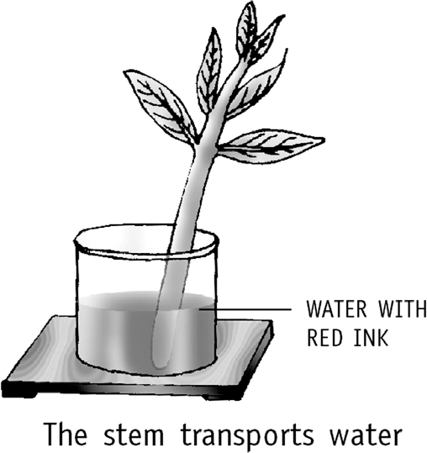
  - Leaves in a Cactus plant are modified to
form spines to prevent loss of water from the surface of the leaves. The green stem in Cactus manufactures food and performs all the functions performed by the leaves in other plants.
10
5.

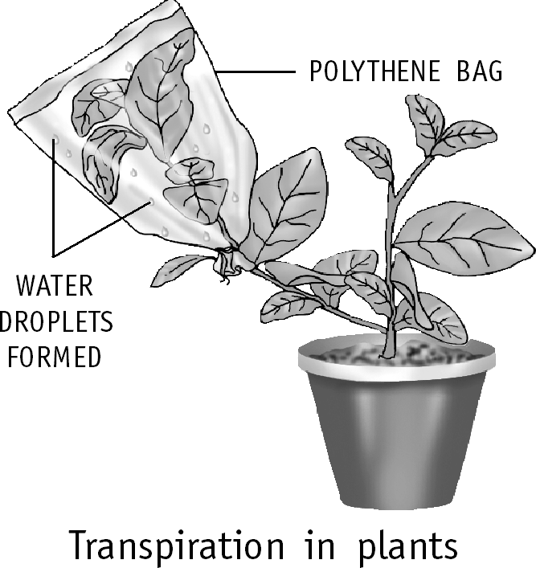
Transpiration helps in cooling down the leaves. As the water escapes from the leaves, the roots pull more water to compensate for this loss. This water brings with it important nutrients required by the plant from the soil.
6.

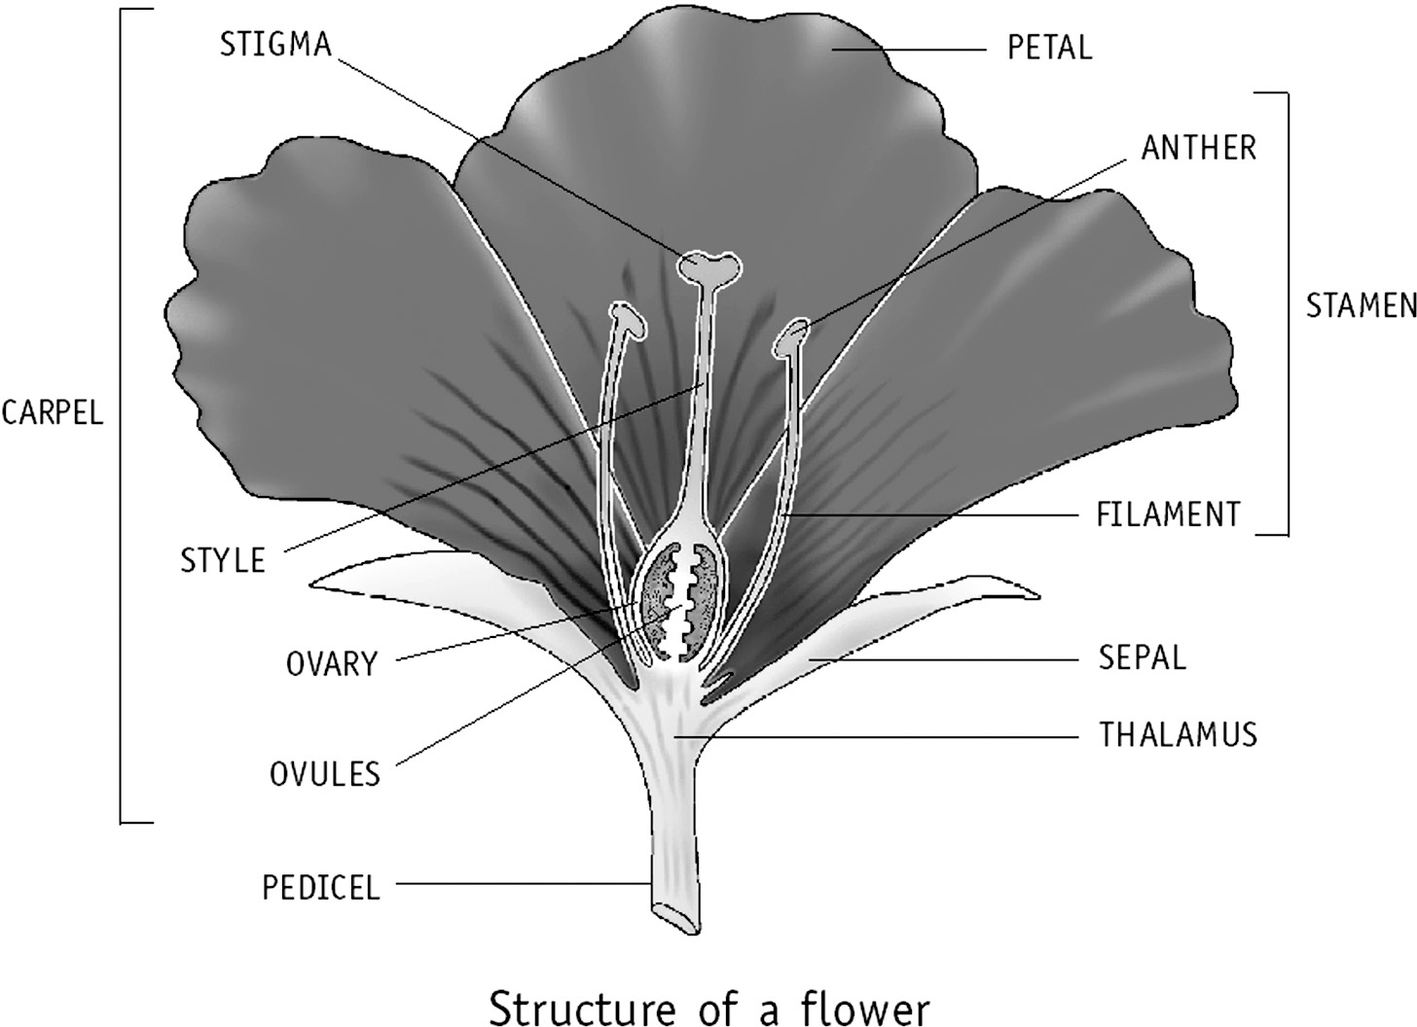

HOTS Questions
- No, because the small mango plant will grow up to be a tree. A herb always remains small.
- Attractiveness of a flower is an adaptation to attract insects for pollination. This adaptation is not necessary in wind-pollinated flowers.
- Green plants synthesize their food from simple non-living substances found in nature – water and carbon dioxide. Making food in the kitchen consists of transforming living things into a kind that we can easily digest.

Be a Scientist
- At noon
- At midnight
- At noon

9. THE BODY AND ITS MOVEMENTS
- 96 Oral Questions
  - Yes, in unicellular organisms
  - different types of cells
  - organ system
  - nervous system
  - reproductive system

- 101 Oral Questions  - Protects the organs in the upper part of the body such as heart and lungs. It also gives a skeletal structure for the human physique.  - bone marrow inside the bones  - skull  - The backbone has 33 small bones called vertebrae joined together. The joints allow the movement of the backbone.  - Ball and socket joint. Hinge joint allows movement in one direction only while ball and socket joint allows movement in all directions.  - No, muscles make the bones move only by pulling.  - 102 Oral Questions  - No, examples are earthworm, snail, cockroach  - human, fish: endoskeleton; crab, cockroach,  snail: exoskeleton  - No. A fish uses its tail fin to push the water and move forward. The side fins are used for balance and for turning.  - Snake has a very flexible backbone. It can curve its body into many loops and each loop pushes against the ground to give the body a forward push. In humans, the backbone is not that flexible.  P. 103 Exercises |  |  |  |  |  | - The three types of skeletons are:  - Exoskeleton: It is a skeleton which is outside the body but is not made up of bones. For example, crabs and snails.  - Endoskeleton: It is a skeleton which is inside the body and made up of bones. For example, humans and fish.  - Liquid skeleton: A liquid skeleton performs the same function as a bony skeleton. For example, earthworms have liquid skeletons. They have liquid trapped in spaces inside the body.  - The forelimbs of birds are modified into wings.  Their bones are hollow and very light.  - 1. Group of organs work together to carry out various life activities in our body. Such a group of organs is called an organ system, for example,  - muscular system: movement of body parts  - excretory system: removes waste from the body  - reproductive system: produces offsprings  2. a. Earthworms: Muscles squeeze against the liquid trapped in spaces inside the body. The muscles can be squeezed differently to change the body shape. These changes in the shape help the earthworm to move
A. 1. d | 2. a | 3. | b | 4. | a | along. To move the earthworm first extends
5. a  9. a | 6. a  10. b | 7. | d | 8. | a | the front part of its body, keeping the rear  part fixed to the ground. Next, it fixes the

- 1. false 2. circulatory
3. digestive 4. true
5. skull 6. one
7. heart, lungs 8. Femur
9. true 10. triceps
11. false 12. true
13. exoskeleton 14. tail fin
15. streamlined shape 16. vertebrates
- 1. A group of cells that performs a special job together is known as a tissue. For example, blood, skin.
- The main organs in the digestive system are teeth, food pipe, stomach, small and large intestine. The main function of this system is to digest and absorb nutrients necessary for growth and maintenance of the body.
- The soft, inside portion of a bone is known as bone marrow. The main function of bone marrow is to produe blood cells.
- The spine allow us to bend or twist our back. It forms the central support for the skeleton and also protects the spinal cord.
- The muscles move the bones by their pull. Muscles cannot push. Therefore to move the bone in one direction at least two sets of muscles are required.
front part and shortens it and pulling rear end forward.
- Snake: Snakes have a long and flexible backbone. They can curve their body into many loops. Each loop pushes against the ground to give a forward push to the body.
- Fish: Muscles enable the fish to move, contract on one side and expand on the other. The tail fin of the fish moves along with the body in a zig-zag pattern and thus pushes the water. This force moves its body forward. Again, fishes have a
streamlined shape which helps in reducing water resistance.
Living Science Companion – 6
- In such joints, the end of one of the bones is round like a ball. It fits into a hollow part (or socket) in the other bone. The bone that ends in a ball can move in any direction. Shoulder joint and hip joint are examples of ball and socket joint. This joint allows movement in all directions.
- The main functions of the human skeleton are
  - Support: The skeleton provides the framework which supports the body and maintains its shape.
11
  - Protection: The skeleton protects many vital

organs like brain, heart, etc.
  - Movement: The joints between bones permit movements.
  - Blood cells production: Blood cells are made in the bone marrow inside the larger bones of the body.
- The joints in the body are the places where two bones are joined together. The joints are of three types, depending on the types of movement they allow – immovable, slightly movable and freely movable.
- Endoskeleton: It is the skeletal system which is present inside the body. For example, humans, fish, birds and so on.
Exoskeleton: It is a skeletal system which is present outside the body. It is not made up of bones. For example, crabs, cockroaches, snails and so on.

HOTS Questions
- The vertebrae provides flexibility as it allows our back to bend, twist and turn at each joint. Freedom of movement and flexibility of body would have been restricted if the backbone had only one long bone.
- No. A fish moves forward by the zig-zag movement of its body and tail fin. The side fins are used for balance, not for moving forward.
- Beating of the heart; movement of stomach muscles for churning the food during digestion.

HALF-YEARLY TEST PAPER
for Chapters 1–9
- 1. Parasites 2. Cabbage 3. Proteins
- Iron 5. Synthetic 6. Wool
7. Yes 8. Gas 9. Evaporation
10. Loading 11. Physical change
12. False 13. False 14. Phototropism
15. Fruit
- 1. Rusting is a chemical change because the rust formed has very different properties from those of iron.
- Leaves of Mimosa plant droop when something touches it.
Living Science Companion – 6
- Plants growing in hot deserts have small
- Distillation involves evaporating a liquid to its vapours and cooling the same so that they condense to give the pure liquid.
- The structural units of non-living things are molecules but the structural units of living things are the cells.
- 1. In case of physical changes, the molecules of the substance remain exactly the same before and after the change. Whereas in chemical changes, the molecules of the original substances undergo changes to form molecules of new substances.
- Cotton cloth is soft and lets air in. It also absorbs sweat. The sweat it absorbs evaporates because of the air it lets in. This results in the cooling down of the body. Synthetic fibres on the other hand do not breathe so well. They
also cannot absorb sweat. So cotton clothes are more comfortable to wear in summer.
- Two ways in which living and non-living things are similar are:
  - Both living and non-living things are made up of matter.
  - Both living and non-living things are made up of structural units.
- The two main functions of roots are:
  - They anchor the plant to the soil. Roots also bind soil particles together and prevent soil erosion.
  - They absorb water, minerals and salts from the soil.
- The backbone consists of 33 small bones called vertebrae. The vertebrae are joined to each other. These joints allow slight movement of the vertebrae. The backbone is attached
to the base of the skull and forms the central supporting rod for the skeleton. The backbone is also called the spine or the vertebral column.
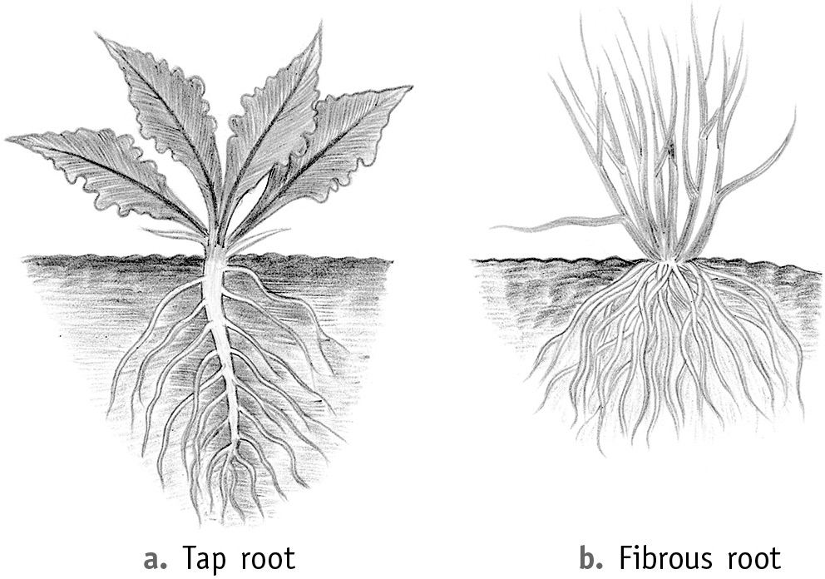6.

leaves to prevent the loss of water from the surface of the leaves.
- Muscles make bones move at the joints.
- Snakes have small teeth, which help them to swallow the prey as a whole.
- Carbohydrates are the nutrients in the food which give us quick energy.
- The rearing of the silkworm for the production of silk is known as sericulture.
- Molecules in a solid can only vibrate about their
12
fixed positions.
tap root

lateral roots

D. 1. a 2. a 3. d 4. c
5. d 6. a 7. c 8. b
9. a 10. d 11. a 12. c
13. c 14. c 15. b

fibrous
roots

10. LIVING ORGANISMS AND THEIR SURROUNDINGS
- 113 Oral Questions
  - ecology
  - No, the natural environment consists of both the biotic and abiotic components, that is, air, water, sunlight, soil, temperature and all living organisms in a place.
  - Auto means self. Green plants. Because green plants make their own food.
  - Air, water, soil, sunlight, temperature
  - No.
- 117 Oral Questions
  - Deserts
  - No, the hump stores fat and it provides food in times of shortage.
  - No, the leaves are reduced to spines to prevent water loss.
  - The long and narrow leaves of tape grass can withstand water currents without getting damaged.
  - Dolphins, whales. They breathe through blowholes located near the upper parts of their heads.
  - Penguins stay together in groups to keep themselves warm.
  - Yes, the brown colour make the lions not clearly visible to their prey as it matches with the surrounding dry grassland.
P. 119 Exercises
A. 1. c 2. c 3. c 4. c
5. c 6. a 7. b 8. d
- 1. living 2. plants
3. ecology 4. autotrophs
5. secondary consumers 6. decomposers
7. salt water 8. true
9. succulent 10. streamlined
11. false 12. snow
13. hibernation 14. camouflage
15. broad
- 1. The study of the relationship between living things and their environment is called ecology.
- During summers a dormouse accumulates lot of fats in its body. When winter comes, it becomes very slow and inactive. So it sleeps through the cold months of winter living off its body fat.
- Grass have flexible stalks so that they bend and do not break in windy conditions. They also have strong roots to anchor them.
- Parrots and toucans eat nuts, and have strong curved beaks to crack open the tough shells.
- Only green plants make their own food from carbon dioxide and water, using the energy of sunlight. So they are called producers.
- This helps them creep up to their prey without
making a sound while hunting.
- a. Plants have long roots that penetrate deep inside the soil in search of water.
  - They have fleshy stems to store water. The stem is also covered with a thick waxy layer that helps to retain water.
- The streamlined bodies reduce resistance due to water and help the water animals to swim fast in water.
- 1. Herbivores: Plant-eating animals are called herbivores. Examples are cows, goats and deer.
Carnivores: Flesh-eating animals are called carnivores. Examples are lions, tigers and wolves.
Omnivores: Animals that eat both plants and animals are called omnivores. Examples are bears, crows and humans.
- Animals depend on plants for food, oxygen and shelter. Plants depend on animals for pollination and dispersal of seeds.
- Biotic components:
  - The living or biotic components include all living organisms. These constitute the biotic or biological environment.
  - The living or biotic organisms of an environment can be divided into three groups, that are producers, consumers and decomposers depending on how they obtain their food.
Abiotic components:
- The non-living or abiotic components include air, water, soil, sunlight, temperature, etc. These constitute the abiotic or physical environment.
- These factors affect the living organisms found in the area.
- An adaptation is a feature that helps an organism to survive in a particular type of an environment. Adaptation leads to evolution. For example, the gills of a fish is an adaptation that helps it to survive in water. Again a camel has several adaptations to help it survive in a desert such as a hump, long legs. Its feet have large soles.
Living Science Companion – 6
- Stick insect uses camouflage to escape from enemies. The tiger uses camouflage to catch its prey. Stick insect resembles very much
to a stick and enemies cannot recognize it. Orange coat of tiger with stripes matches its surroundings. This way a tiger moves closer to its prey and catches it.
- a. Camel
  - It has a hump where fat is stored. This provides it with food in times of shortage.
13
  - It can drink a very large quantity of water

at a time but it loses very little water in the form of urine, dung or sweat.
  - It has long legs that keep its body away from heat of the sand.
    - Water lily
- The stems are long and narrow to withstand water currents without getting damaged.
- Floating leaves are large and flat. They have waxy upper surfaces to make them waterproof.
- The roots are much reduced in size.
    - Fish
- They have streamlined bodies. This helps them swim fast in water.
- Their body is covered with scales and mucous to make it waterproof.
- They have gills for breathing under water.
- Lions have eyes in front of their faces, this helps to give them a correct idea of their prey. While the deer have eyes on the side, this enables them to look in all directions for danger.

HOTS Questions
- No, because fungi, together with bacteria are responsible for most of the recycling which returns dead material to the soil in a form in which it can be reused. Without fungi and bacteria, these recycling activities would not take place. We would effectively be lost under piles many metres thick of dead plants and animal remains.
- No, because dolphins and whales do not have gills to breathe under water. They have to come up to the water surface to breathe.
- Before entering hibernation, animals eat a large amount of food and store energy in fat deposits in order to survive the hibernation period. This stored fat lasts longer because their body activities are slowed down.
- Carnivores eat herbivores for their food. If there were more carnivores than herbivores in a habitat then carnivores would eat all the
herbivores. So the balance of the habitat would get disturbed. Therefore, in a habitat, herbivores are expected to be in greater number.
Living Science Companion – 6
- All organisms other than bacteria and fungi feed on dead plants and animals but they cannot decompose them into nutrients which are returned to the soil. On the other hand, bacteria and fungi are responsible for the recycling process which returns nutrients back to the
soil in a form which can be used by plants. So bacteria and fungi are called decomposers.

Be a Scientist
- a. There are very few trees. (Monkeys are adapted to living on trees)
14
- b. There is no fresh water.

11. MEASUREMENT AND MOTION
- 129 Oral Questions
  - speed of a car, distance from earth to sun
  - No.
  - metre, kilogram, second
  - a. 10 kg b. 5 cm c. 1 kg d. 20 cm
- 132 Oral Questions
  - Yes. A person inside a moving car can be in motion with respect to a building on the
roadside but will be at rest with respect to the car itself.
  - Both A and B because both rectilinear and curvilinear are kinds of translatory motion.
  - Because, the outer portions of the top move through a greater distance than the inner portions. This type of motion is called rotational motion.
  - The revolution of earth is a translatory motion and the rotation of earth is a rotational motion. Another example is bicycle wheel having both rotational motion and translatory motion while moving.
P. 134 Exercises
A. 1. b 2. c 3. c 4. b
5. c 6. b 7. c 8. b
9. d 10. a
- 1. physical 2. true 3. true 4. 1960
  - true 6. false
7. translatory motion 8. rotational motion
9. oscillatory motion 10. fast periodic motion
11. wheels of a car
- 1. Standard units are used in measurement because they remain same everywhere and does not change. This makes measurement easier.
- CGS system (centimetre, gram, second) SI system (metre, kilogram, second)
- To make accurate measurements we must use appropriate measuring instruments and also know how to use these instruments properly.
- An object is said to be in motion if its position changes with time, in relation to a stationary object in its surroundings.
- The invention of the wheel and the invention of the steam engine brought about revolutions in transport.
- Rotational and translatory motion.
- 1. Because calculations with very large or very small numbers become very difficult and, therefore, impractical.
- (i) Keep the ruler exactly along the length to be measured.
- Avoid using worn out portions of the instrument.

- Keep the eye vertically above the point where the measurement is to be taken.
- Two methods we can use to measure the length of a curved line are: by using a thread, by using a divider
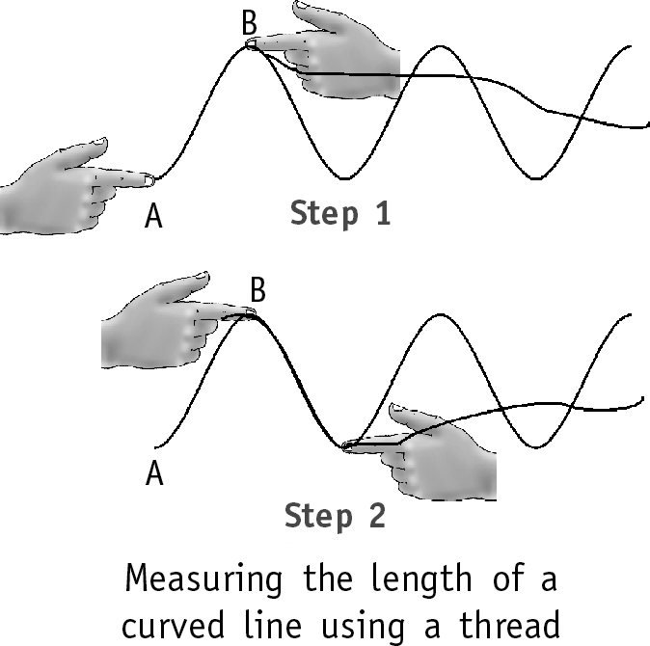
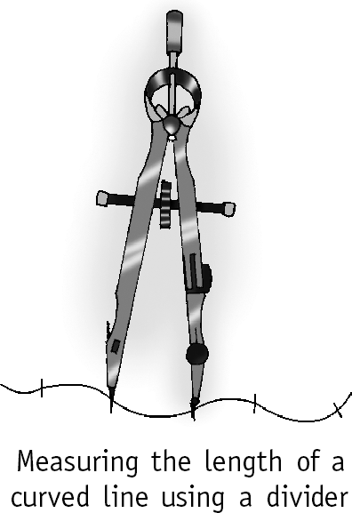
- a. Accurate measurement is necessary while conducting an experiment in the laboratory.
b. Only estimation is required while cooking in the kitchen.
Because in a experiment, a slight mistake can lead to wrong result but in cooking a curry,
a minor error in measurement will make no difference to its taste.
- Translatory motion is of two kinds.
  - Linear or rectilinear motion – when the object moves in a straight line, for example, a car running on a straight road, a bullet fired from a gun.
  - Circular or curvilinear motion – when the object moves along a curved path, for example, a cyclist going along a circular track.
- If the same motion occurs again and again, it is said to be repetitive motion. Repetitive motion that repeats itself at regular intervals of time is called periodic motion. For example, pendulum of a clock and revolution of the earth around the sun.

HOTS Questions
- No, we do not measure everything accurately in our daily lives. We estimate a number of things, for example, how much sugar to put in a
cup of tea, or how long to boil an egg.
- Rotational and translatory motion
- Two kinds of rotational motion with different axis of rotation.
- Rotational and translatory motion.
- Yes, with respect to all other heavenly bodies in the universe except the earth.

12. LIGHT, SHADOWS AND REFLECTIONS
- 141 Oral Questions
  - speed of light
  - non-luminous objects
  - No. opaque
  - tracing paper, ground glass
- 146 Oral Questions
  - No, as the light will not be obstructed by the object.
  - Yes, but we need an object so that it obstructs the light from the luminous body.
  - In both the cases
  - False. It can be of the same size, smaller or bigger than the object depending on the distance of the object from the pinhole as
compared to the distance of the screen from the pinhole.
  - true
  - A red shadow can be formed when a semi- transparent red-coloured glass or plastic sheet is placed in the path of a light source.
  - The ray of light will be reflected by the plane
mirror to a different direction.
P. 147 Exercises
A. 1. b 2. d 3. b 4. b
5. c 6. c 7. d 8. a
- 1. no 2. non-luminous
3. luminous 4. true
5. no 6. on a new moon day
7. true 8. false
9. moon 10. translucent
11. image 12. no
13. yes
- 1. Light travels from the sun to the earth in 8¼ minutes. So we see the sun rising 8¼ minutes after it has actually risen.
Living Science Companion – 6
- Sun, firefly are natural sources of light. Candle, electric bulb are artificial sources of light.
- When light falls on a non-luminous object, it gets reflected in different directions. When this reflected light reaches our eyes, we can see the object.
- The property of light of travelling in straight lines is called rectilinear propagation of light.
- Translucent objects are those objects that allow some light to pass through but not enough to enable us to see clearly through it.
15

Examples are butter paper and ground glass.
- A shadow is formed when light from a source is obstructed by an opaque object.
- During a solar eclipse, the dark side of the moon faces the earth. Therefore, a solar eclipse always occurs on a new moon day.

- We can see an image of an object in a plane mirror when light from the object reaches our eyes after reflection from the plane mirror.

- 1. We depend on light energy for food, oxygen and fuel because green plants prepare food using the energy of light. Similarly the energy of all fossil fuels, such as petroleum, coal and natural gas has also been derived from the light energy of the sun.
- Take three rectangular pieces of cardboard. Make holes in them at exactly the same level. Make them stand straight on a table using wooden supports. Keep a burning candle on the table, with its flame at the level of the holes. Now adjust the cardboards so that we can see the candle flame through the holes.
We will find that the flame can only be seen when the holes are exactly in a straight line. This proves that light travels in straight lines.
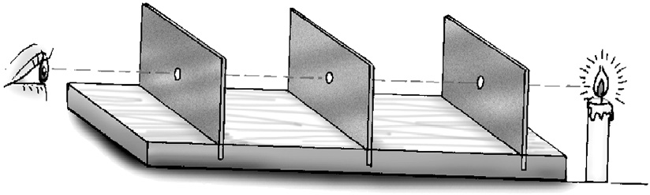
- (i) A shadow is black in colour.
  - It is similar in shape to the object.
  - It does not show any details of the object.
- a. Region C
b. Region between A and B

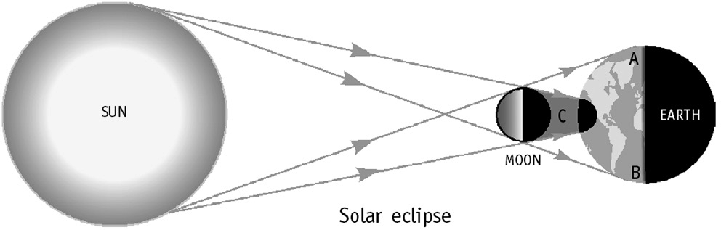

- The differences between an image and a shadow are:
Living Science Companion – 6
  - A shadow is black while an image is of the same colour as the object.
  - A shadow is similar in shape to the object, but shows no other details about the object. An image is not only of the same shape as the object but has all the details that the object has.
16
6.
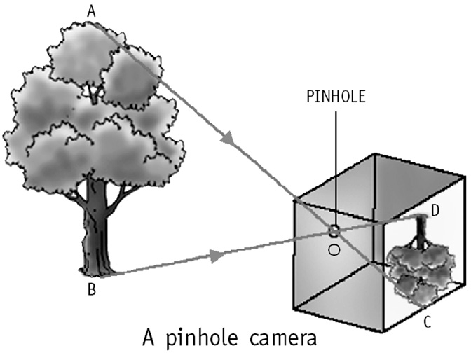
7.

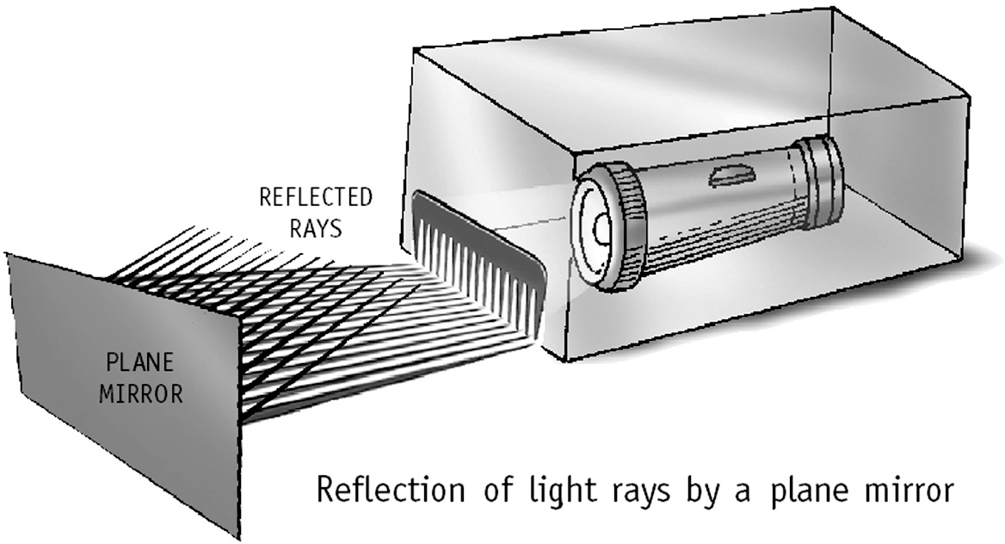

HOTS questions
- A translucent object will form a shadow. Darker, because no light can pass through an opaque object.
- Yes, when there are more than one sources of light. A shadow is formed from each light source present in a scene. Therefore, two or
more shadows can be formed at the same time by the object.
- Black
- A pinhole camera forms an image since it is formed by light from the object actually falling on the screen.
- Yes, if the distance of the object from the pinhole is smaller than the distance of the screen from the pinhole.

Be a Scientist
Professor Photon’s logic is not correct since a total solar eclipse occurs when the moon completely covers the sun, as seen from the earth, and the sun does not cool down at that time.

13. ELECTRICITY AND CIRCUITS
- 154 Oral Questions
  - a. electric cell b. switch c. wires
  - from P to N

  - No, because the circuit is broken
- 157 Oral Questions
  - No, some liquids can conduct electricity, for example, pure water, salt solution, lime juice
  - Bare wires can give us electric shock and a coating of plastic insulates the wire.
  - A car battery, cell of a mobile phone
  - solar energy
P. 158 Exercises
A. 1. d 2. c 3. d 4. b
  - a (the conductivity of pure water is very small as compared to normal tap water)
6. d 7. c 8. c 9. b
- 1. switch 2. no
3. conductors 4. positive, negative
5. true 6. electrical
7. positive 8. false
9. no 10. true
11. fused 12. no
- 1. The path for electric current to flow from
the positive terminal of a battery to the
negative terminal is known as an electric circuit.
- When the circuit allows the flow of current it is
said to be complete or closed.
- Electricity cannot flow in an open circuit because the path of the current is obstructed and it can no longer flow through the wire.
- An electric cell is needed in an electric circuit to supply electricity.
- The function of the switch is to break or complete the electric circuit.
- Ordinary dry cells can supply electricity for a certain time but chargeable cells can be used again and again by charging them.
- 1. a. a bulb
- 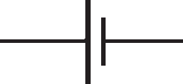an electric cell
- a switch
- a battery of electric cells
- An electric circuit showing flow of electric current.

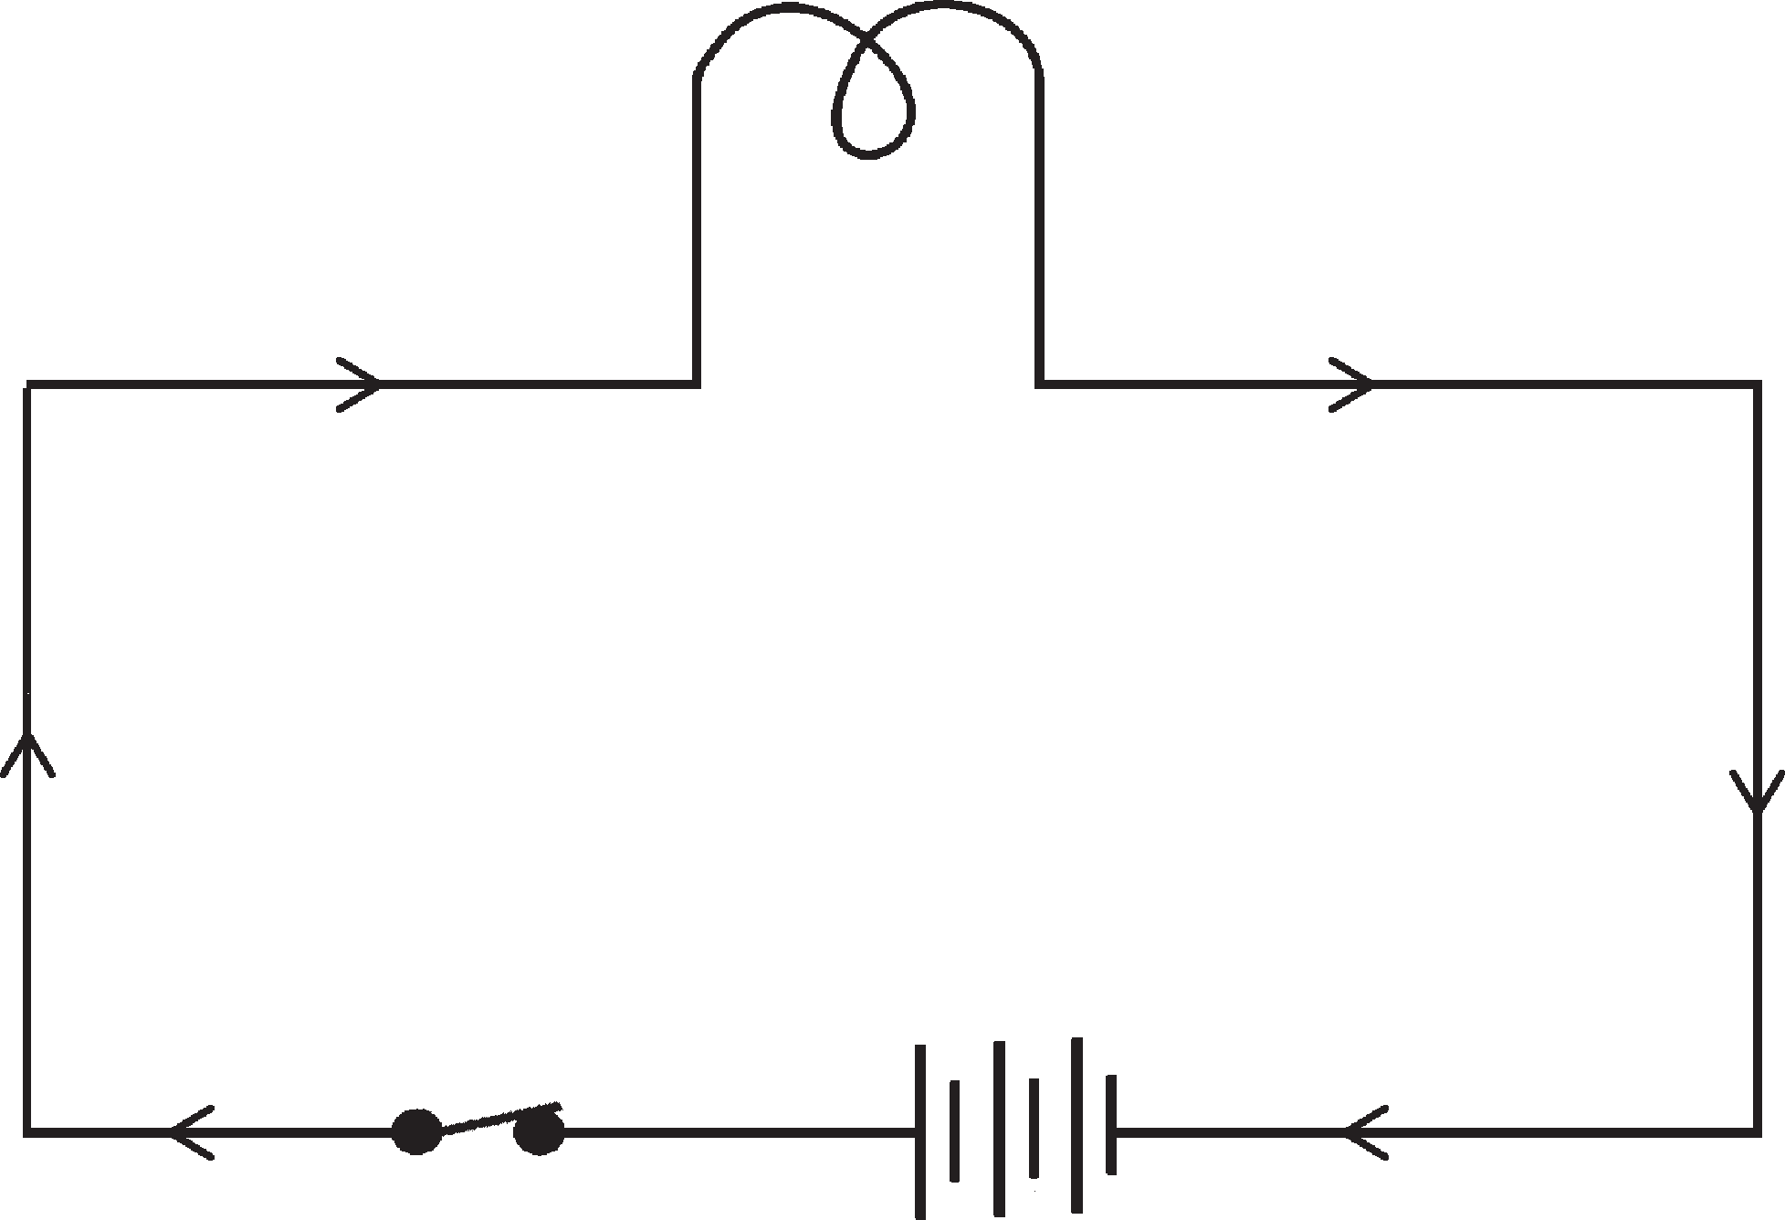
- Conductors:
  - A substance that allows electric current to flow through it is called a conductor of electricity.
  - Copper, graphite and tap water are conductors.
Insulators:
- An insulator or non-conductor does not
allow electric current to flow through it.
- Plastic, rubber and kerosene are insulators.
- No. Because aluminium is not an insulating material like plastic, but a conductor of electricity. So, aluminium foil will not prevent us from getting electric shocks while handling electric wires.
- A solar cell is a cell that directly converts solar energy into electrical energy.
Uses of solar cells:
  - Solar cells are used to give electrical power to human-made satellites in outer space.
  - They are also used to give power to street lights.
- Electricity is generated in power stations and brought to our houses by wires.

HOTS Questions
- No, current will not flow in the circuit because plastic is an insulator and hence, will not allow electric current to flow through it.
- Silver is more conductive, but due to its cost (more expensive than copper or aluminium) it is not used in most cases.
- Conductor because it allows electric charge to travel through it easily.
- Charges may flow through us if we are earthed (in contact with the ground). If we are standing on an insulator such as rubber slippers we
are no longer in contact with the ground, and
charge can no longer flow through us.
- Inside the cell, the current flows from negative
to positive terminal
- In outer space, no other source of electricity is available except solar energy. So, only solar cells are used as a source of power in satellites.

14. FUN WITH MAGNETS
- 166 Oral Questions
  - No, I do not agree. Substances like gold, silver, copper are non-magnetic substances.
  - No, in a bar or horseshoe magnet the regions of strongest magnetic strength are near the ends called poles.
Living Science Companion – 6
  - This is because the magnet aligned itself in
attraction to the earth’s magnetic field.
  - 10 north poles and 10 south poles
  - Yes. If both ends are attracted by the north pole, then it is a simple iron bar, not a magnet.
- 167 Oral Questions
  - Yes, this is done by stroking the piece of iron from one end to the other with one pole of the magnet.
17

  - Because, magnets tend to become weaker after some time if their poles are left free.
  - All around the magnet, magnetic field
  - Electric motor in fan, picture tube of television
P. 168 Exercises
A. 1. a 2. c 3. d 4. a
5. a 6. d 7. c 8. d
- 1. false 2. repel, attract
3. South 4. no
5. single touch method 6. false
7. true 8. field
9. magnetic compass 10. keepers
- 1. Freely suspended magnet points in the
north-south direction. This is because the earth itself behaves like a huge bar magnet with its magnetic poles near the geographical North and South Poles. In a freely suspended magnet,
the North Pole points towards the geographical North Pole since it is attracted by the earth’s magnetic South Pole. Similarly, the South Pole of the suspended magnet is attracted by the earth’s magnetic North Pole and, therefore, points towards the geographical South Pole.
- We will get two separate magnets each with its north and south poles.
- No, because copper is a non-magnetic substance.
- Unlike poles attract and like poles repel each other.
- Because a magnet loses its magnetism, if it falls from a height.
- Magnetic keepers are used to store magnets in order to avoid self-demagnetization.
- 1. Put some iron filings on a sheet of paper. Roll a bar magnet in the filings and then lift it up. We will find that most of the iron filings stick to the magnet at the ends. There are fewer iron filings in between and almost none at the centre. Thus, in a bar magnet the regions of strongest magnetism are near the ends called the poles of a magnet.
2.
Living Science Companion – 6

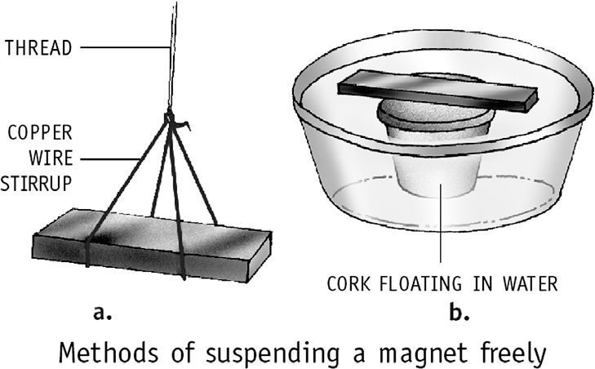
- Bring one pole of a magnet close to the ends of the magnetic material, one end at a time. If one end is attracted and the other repelled, the
18
magnetic material is a magnet. If both ends are attracted, the magnetic material is not a magnet.
- Place an iron nail or a bar on a table. Hold it down firmly and stroke it about 30 times, from one end to the other with one pole of a bar magnet. After you reach the other end, lift the magnet high and bring it back to the first end. We will find if we stroke with the north pole of the magnet, the end of the iron bar from which the stroking is started (end 1) becomes the north pole. The other end (end 2) becomes the south pole. If we stroke with the south pole, poles in the iron needle will be reversed.
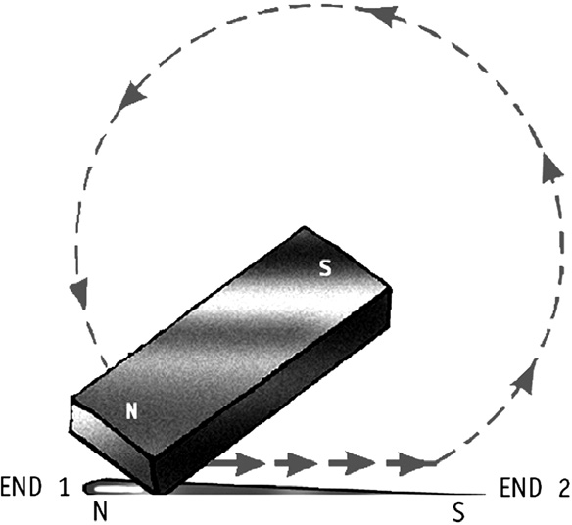

- Magnetic compass: A compass consists of a magnetized needle pivoted at a point so that it is free to rotate about that point. The needle points in the north-south direction provided
it is kept away from another magnet or other magnetic materials.
- Three uses of magnets are:
  - In refrigerator door stickers.
  - In electric motors used in fans and other electrical appliances.
  - In speakers, microphones, picture tubes of televisions and computer monitors.

HOTS Questions
- Compass is better as it can be used at any time of the day or night and in any weather. Stars can only be seen at night on a clear night. So they cannot be used during the day or in cloudy nights.
- No.
- By repulsion of like poles of powerful magnets.
- If we suspend the bar magnet freely, it will align itself in the north-south direction. The north pole of the bar magnet points towards the north direction. Now, with reference to the north direction, we can find the west direction.

Be a Scientist
The container of the compass was made of steel which is a magnetic material. It should have been made from a non-magnetic material such as aluminium.

15. WATER
- 177 Oral Questions
  - This is due to the following reasons: a. We cannot use directly the salty water from seas and oceans (more than 97 %). b. Water is not evenly spread on the earth. c. There is shortage and pollution of sources of water.
  - Yes
  - ice, water vapour, water
  - temperature
  - by cooling the air
  - Because, water evaporates faster in the sun.
- 182 Oral Questions
  - false
  - droplets of water. Water vapour gets cooled by the cooler air higher up in atmosphere and condenses to form water droplets. Many such droplets together form clouds.
  - The impurities are dust particles and some gases. They get dissolved while it rains. Where the air is polluted, the rainwater may contains harmful substances like acids.
  - Because, monsoon winds lose most of their moisture by the time they reach Rajasthan.
  - In a big city, because, there is less vegetation due to cutting down of trees and less open space due to construction of buildings and roads.
P. 183 Exercises
A. 1. b 2. b 3. a
4. d 5. a 6. d
7. c 8. b 9. b
- 1. true 2. 70
3. atmosphere in 4. true the form of water
vapour
5. freezing, heating, 6. hot water melting
7. boiling 8. condensation
9. false 10. false
11. true 12. water table
13. true 14. cannot
15. true 16. true
17. cyclones 18. harvesting
- 1. The three states of water are solid, liquid and gas.
- Solid – ice, liquid – water, gaseous – water vapour
- If the substance is hotter, then evaporation will be faster, that is, the higher the temperature, the more the evaporation. In fact, evaporation will take place from the surface of a liquid at all temperatures. The effect of temperature is to affect the rate at which evaporation will take place. Evaporation occurs even when liquid water is at 0 °C.
- Water vapour condenses when it reaches high up in the atmosphere because the air higher up in the atmosphere is cooler. This cools the water vapours and it condenses to form water droplets.
- As the clouds get cooled further, water drops become bigger and when they become too heavy, they fall on the earth as rain.
- a. freezing b. melting c. condensation
- The groundwater may run along the surface of the non-porous rocks and come out of the surface at some places to form a natural spring.
- Three uses of water are:
  - Water is essential for drinking, cooking and washing.
  - It is used in dams to generate electricity.
  - A large amount of water is used in agriculture and industries.
- The constant circulation of water from the earth to the atmosphere and back to the earth again is known as the water cycle.
- 1. Water is so important for our body because it is essential for life. Several life processes such as digestion of food, absorption of nutrients by the body and so on need the presence of water. It also helps to control our body temperature.
- In plants, water is essential for germination of seeds and their growth as well. It also helps to transport nutrients from the soil, and food from the leaves to different parts of the plants. Plants use water, along with CO2 from air to
make food in the presence of sunlight known
as photosynthesis.
- Take water in a beaker and add a few ice cubes to it to make the water cold. Keep it for some time on the table, and then observe
the beaker. We see tiny drops of water on the outside of the beaker. As the air in contact with the beaker cools down, the water vapour
present in the air condenses to form water. This shows that water vapour is present in the air.
- Overuse of groundwater is causing the water table in cities to go down rapidly resulting in the lowering of water table.
Living Science Companion – 6
- Lack of water influences crop growth in many ways. Because droughts gradually lead to the reduction in soil fertility, plant growth and crop yield is affected, as a result the prices
of grains, fruits and vegetables go up. Yes, because all the crops get washed away in the flood water.
- The strong wind causes high waves, called tidal waves, in the sea. They cause flooding. In coastal areas, flooding is often caused by cyclones.
19

- The four ways in which we can conserve water are:
  - Avoid wastage of water, and recycle wherever possible.
  - Plant trees and other vegetation. This increases the absorption of water by the soil and increases the water table.
  - Control flooding and store water for use.
  - By rainwater harvesting, which consists of storing rainwater for later use.
- Big dams destroy wildlife and displace people from their homes. Also accumulation of silt in the storage reservoir reduces their effectiveness with time.
- Rainwater harvesting is storing rainwater for later use. The two ways in which it can be done are:
  - The water falling on the roof of a building is allowed to flow into a storage tank and used for daily activities. Or it is allowed to flow into a deep pit to recharge groundwater.
  - The rainwater flowing into roadside drains is allowed to flow into deep pits so that it adds to the groundwater.

HOTS Questions
- There is a limited amount of water on the earth, which would have been consumed long back if it had not been recycled by nature. This all life on earth would have died long back.
- Rainwater harvesting.
- Candle-wax, butter or ghee

16. AIR AROUND US
  - 190 Oral Questions
    - thinner
    - a mixture. It is a mixture of mainly nitrogen, oxygen, argon, carbon dioxide and small amounts of other gases. Again varying quantities of dust, smoke and water vapour are also present in air.
    - No, it varies in the air from place to place and from time to time.
- 193 Oral Questions
  - false, as for example, fishes breathe through
Living Science Companion – 6
gills.
  - Yes, plants use oxygen for respiration during the day also. But the oxygen released during photosynthesis is more than the oxygen used up in respiration.
  - The solubility of air in water reduces as the temperature increases.
  - Yes, by the rotation of windmills
  - Yes, the atmosphere absorbs some part of the sun’s heat and reflects the rest. Again in the night, the trapped heat prevents the earth from cooling down too much.
20
P. 194 Exercises
A. 1. d 2. a 3. d
4. b 5. c 6. b
7. c 8. b 9. d
- 1. atmosphere 2. nitrogen
3. nitrogen 4. respiration
5. false 6. oxygen, carbon dioxide
7. false 8. carbon dioxide
9. gills 10. true
11. oxygen
- 1. Atmosphere is the blanket of air surrounding the earth.
- Carbon dioxide is considered to be so important because plants use carbon dioxide for preparing food which in turn gives food to the entire living world.
- The amount of water vapour in the air is known as humidity.
- Breathing in is necessary process in order to keep animals and humans alive. It allows animals and humans to take in oxygen.
Whereas energy required for the survival of organisms is produced through the process of respiration.
- Fish breathe through their gills.
- Yes, plants require nitrogen for their growth.
- The ozone layer prevents harmful rays of the sun from reaching the earth. These rays, called ultraviolet rays, can cause eye problems and skin cancer.
- Air is said to be polluted when it is contaminated by undesirable substances known as pollutants.
- 1. Air mainly contains nitrogen (78%) and oxygen (21%). The remaining 1% is made up of
argon (about 0.9%), carbon dioxide (0.03%) and small amounts of other gases. Varying quantities of dust, smoke and water vapour are also present in the air.
- Dust and smoke in the air are harmful for our respiratory system. Fine hair and mucus present in our nostrils filter them out and
prevent them from getting into our respiratory system. That is why it is unhealthy to breathe through our mouth.
- Water lily leaves have stomata on the upper surface because lower surface of water lily is submerged and stomata are required for
gas exchange in plants. So in water lilies, the stomata are located on the upper surface of leaves where it comes in contact with air.
- The natural cycle of consumption of oxygen by respiration and burning, and its release by photosynthesis is called the oxygen cycle.
- Air is useful to us in many ways:
  - It helps in breathing.

  - Wind helps to rotate the windmills, run flour
mills and generate electricity.
  - It helps in the dispersal of seeds.
  - It helps the birds, insects and bats to fly.
- The heat and light of the sun fall on the earth’s atmosphere. Some of it is absorbed by the atmosphere, while the rest is reflected back. This prevents the earth from becoming very hot during the day. At night, the trapped heat in the atmosphere prevents the earth from cooling down too much. The atmosphere, thus acts like a blanket around the earth and helps to keep the earth’s surface at the right temperature for life to exist.
- (i) To use food waste and plant waste such as leaves to make compost.
- To save energy, including electricity – this will result in reduction in burning of fuels.
- To use bicycles and public transport instead of private vehicles, as much as possible.

HOTS Questions
- Condensation of water droplets on the outside of a tumbler containing ice-cold water.
- a. It is good to sleep under a tree during the day as the tree gives out oxygen.
- It is not good to sleep under a tree since the tree gives out carbon dioxide at night.
- Exposure to ultraviolet rays due to the depletion of ozone layer in the region.
- Because the force of gravity becomes lesser as we go higher up. So this is unable to hold the air.
- When the water got warm, the solubility of air reduced. The air (including oxygen) dissolved in the water escaped. So all the fish died as they did not get oxygen in the water.

Be a Scientist
Jar 4 (maximum time) → Jar 2 (amount of oxygen in air is 1/5th of the volume of Jar 2, which is less than the amount of oxygen in Jar 4) → Jar 1 → Jar 3 (no oxygen)

17. GARBAGE IN, GARBAGE OUT
- 202 Oral Questions
  - waste derived from living things, and waste derived from non-living things that were once alive
  - recycle
  - It helps reduce amount of energy required to manufacture new products. It also saves on landfill space utilized for garbage disposal and makes the surroundings cleaner and healthier.
  - biodegradable
  - Refuse, for example, we can refuse plastic bags from the shopkeeper while shopping. We
should carry our own jute or cloth bag.
P. 203 Exercises
A. 1. c 2. a 3. a
4. c 5. a
- 1. a. recycling b. landfill
- a. biodegradable b. biodegradable
- nonbiodegradable d. biodegradable
e. biodegradable f. nonbiodegradable
- composting
- decay, nonbiodegradable
- compost 6. vermicomposting
7. false 8. true
9. Recycling of waste 10. plastic
- 1. Biodegradable waste:
  - Biodegradable waste is waste that will decay and mix with the soil.
  - This includes food waste such as fruit and vegetable peels, meat and bones, etc.
Nonbiodegradable waste:
- Nonbiodegradable waste is waste that will not decay and mix with the soil.
- This includes plastics (for example, bags and packaging material) metal glass, etc.
- There is a need to segregate the two types of waste because different kinds of waste require different methods of disposal.
- Because it is a natural process that recycles the nutrients in the waste to yield manure or compost.
- Nonbiodegradable waste cannot be degraded by living organisms.
- Vermicomposting is a method of composting where compost is made from biodegradable waste with the help of a type of earthworms called redworms.
- The old items of metals are taken to factories where these are melted to make new metal products.
- 1. The amount of garbage is so huge that disposing it off is an immense problem. It cannot be burnt as this generates smoke and poisonous gases. It cannot be thrown into water as it will pollute the water.
- Recycling of nonbiodegradable waste becomes so essential these days because over the last few years, we have started buying a number
Living Science Companion – 6
of products packaged in cans, aluminium foils, plastics, etc. We then throw away the packaging. This has lead to an immense increase in the amount of nonbiodegradable
waste and that is why recycling of these wastes has become very essential.
- Recycling is considered to be an efficient method of disposing off garbage because it reduces the amount of waste that is thrown into the community dustbins thereby making
21

the environment clean and the air fresher to breathe. A large portion of garbage can be recycled or converted to compost by a natural process, and only a small portion of it is real waste that has no use and has to be discarded.
- At home we can use part of paper for covering books, and selling the rest to the waste collector for recycling. It is recycled by making paper carry-bags or is used for making recycled paper.
- Because careless disposal of plastic bags chokes drains, blocks the soil and hinders the absorption of water by the soil. If eaten by animals such as cows, it can choke and kill them. Plastic bags can also contaminate foodstuffs because of poisonous dyes getting absorbed into food. If burnt for disposal, they give out harmful gases, which cause pollution and health problems.
- The five ways in which we can contribute to a
better disposal of waste are:
  - Carrying our own cloth or jute bag when going for shopping.
  - Reusing the plastic bottles of soft drinks for storing water.
  - Digging a compost pit in our garden and putting all the biodegradable waste into it.
  - Segregating the waste in the house and put them into separate bins and disposing off separately.
  - Trying to sell all the recyclable items to the waste collector.
- The four Rs of waste disposal are:
  - Refuse things that increase garbage.
  - Reduce garbage by consuming less and throwing less.
  - Reuse wherever possible.
  - Recycle the waste to save resources.

HOTS Questions
- Earthworms are the friends of farmers because they not only aerate the soil but also help in producing vermicompost, a valuable resource for improving soil fertility. They also help in water to drain from soil.
- By composting, as it recycles the nutrients in the waste to compost without causing pollution. Burning of leaves leads to air pollution.
Living Science Companion – 6
- A waste collector is a friend of the environment because he helps in the reusing and recycling of biodegradable and nonbiodegradable waste. Thus preventing pollution and conserving energy.
- Because the quantum of plastic disposed off in the form of plastic bags is many times more than the quantum disposed off as other plastic products such as TV cabinets and buckets.
22
This is because plastic bags may be disposed off after a single use, whereas one bucket may be disposed off after several years of use.

ANNUAL TEST PAPER
for Chapters 10–17
- 1. Deficiency diseases 2. Classification
3. Ecology 4. Decomposers
5. streamlined 6. Small leaves
- Name of the unit of measurement
- At rest 9. A form of energy
10. Lunar eclipse 11. Air
12. Normally 6 cells 13. Poles
14. South pole 15. Distance of 1 cm
- 1. A filter has fine holes which allow the liquid to flow through but not the insoluble solid particles.
- Plants do not move around as they make their food themselves.
- Leaves of the plants that grow under water are long and narrow to withstand water currents without getting damaged.
- The two kinds of translatory motion are linear or rectilinear motion and circular or curvilinear motion.
- A shadow formed by an object is always black whereas image formed by an object is of the same colour as the object is.
- When a current flows through an electric bulb, electrical energy gets converted into light and heat energy.
- This property of water helps to control its temperature and enables aquatic plants and animals to survive in very hot or cold conditions.
- As the clouds get cooled, the water drops become bigger. When they become too heavy, they fall on the earth as rain.
- Atmospheric pressure decreases as we go higher up. To maintain the atmospheric pressure at the normal ground level, an aeroplane is filled with air and sealed.
- The electric current will flow from the positive terminal of the battery to the negative terminal of the battery through the bulb.
- 1. Movement of an object, where it moves around an axis, and its different parts move through different distances in a given time is called rotational motion. For example, the motion
of the blades of a fan and a giant wheel are rotational motions.
- A translucent object allows some light to pass through, but not enough to enable us to see clearly through it, for example, butter paper. An object that allows all the light falling on it to

pass through is called a transparent object, for example, air.
- A magnetic compass consists of a magnetized needle pivoted at a point so that it is free to rotate about that point. The needle points in north–south direction provided it is kept away from another magnet or magnetic materials.
A magnetic compass is used to determine the directions, specially useful for sailors.
- In rooftop rainwater harvesting, the rain water falling on the roof of the building is allowed to flow either into a storage tank or is allowed to flow into a deep pit in the ground so that it adds to groundwater.
- Three important advantages of recycling waste are:
  - It leads to reduced consumption of raw materials.
  - It reduces the amount of energy required to manufacture new products.
  - It reduces environmental impacts arising from waste treatment and disposal. It also makes the surroundings cleaner and healthier.
6.

D. 1. a 2. a 3. b 4. c
5. b 6. a 7. a 8. d
9. d 10. b 11. c 12. c
13. b 14. c 15. b

Living Science Companion – 6

H H H H H

23

ASSESSMENT FOR ENRICHMENT ACTIVITIES

The assessment can be on a 5-point scale. The general points for four types of activities are given below.
Teachers will need to prepare specific rubrics for each activity based on these points.

- For a research and presentation activity, the following points can be used for assessment. Each of these can be assessed on a 3-point scale – 0, 0.5 and 1.
  - Sincerity in gathering material from varied sources
  - Shifting the material intelligently and choosing relevant portions
  - Drawing valid conclusions
  - Making a logical presentation in his/her own words
  - Showing originality of thought

- For an experimental activity, the following points can be used for assessment. Each of these can be assessed on a 3-point scale – 0, 0.5 and 1.
  - Understanding the purpose of the experiment
  - Planning of the experiment by making a complete list of equipments used and procedure to be followed
  - Following the procedure correctly
  - Getting clear, correct and well organized experimental results
  - Stating the conclusions clearly, supported by the experimental data and results

- For a model-making activity, the following points can be used for assessment. Each of these can be assessed on a 3-point scale – 0, 0.5 and 1.
  - Understanding the purpose of the model
  - Planning of the model by making a complete list of equipments used and procedure to be followed
  - Following the procedure correctly
  - Using originality in solving problems encountered while making the model
  - How well the model works

- For a field trip activity, the following points can be used for assessment. Each of these can be assessed on a 3-point scale – 0, 0.5 and 1.
  - Curiosity and excitement shown
  - Resourcefulness in getting facts and information
  - Initiative taken
  - Relating classroom learning to the knowledge gained from the trip
  - Cooperation with one another in the group (as most trips will be group tasks)
Living Science Companion – 6

24

